

Faculty of Computer Technology
Assam down town University, Assam, India

Name | Richard Chingshubam
Enrollment ID | ADTU/1/2025-28/BCAO/002
Semester | 2
Section | C
Course Title | ARRAY

Assessment Report

Problems Attempted | 22
Problems Solved | 22
Accuracy (%) | 71.4
Rank | 4603
Score | 9

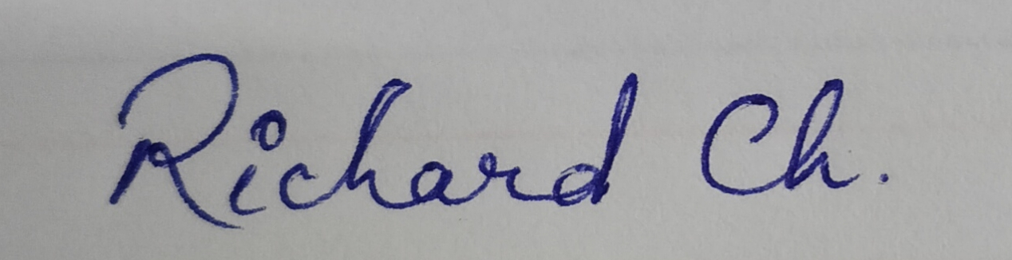
Student Signature: _____________________

